Familiarization of Wireshark Tool
Name: Paulson K Babu
Date: 21/11/2025

Tasks:Protocol Packet Capture
(http, https, tcp, dns, ftp, udp),Three-Way Handshake, ICMP Echo Request/Reply,Highest Number of Packets Shared Between Two IPs,Most Packets Shared IP.
HTTP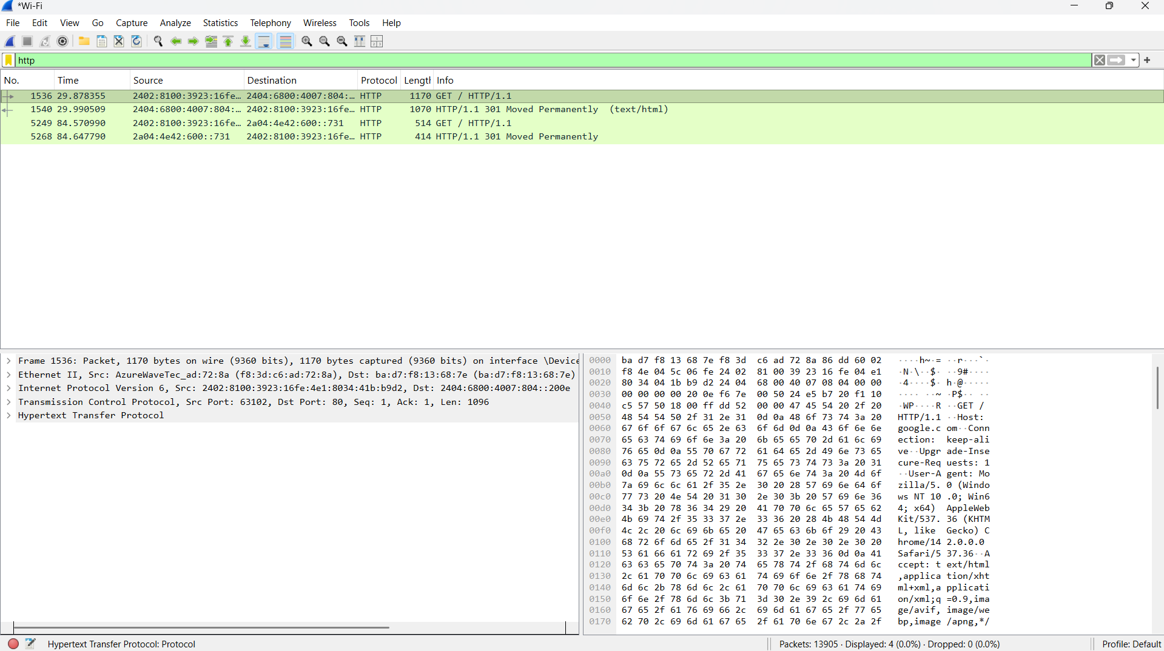

HTTPS
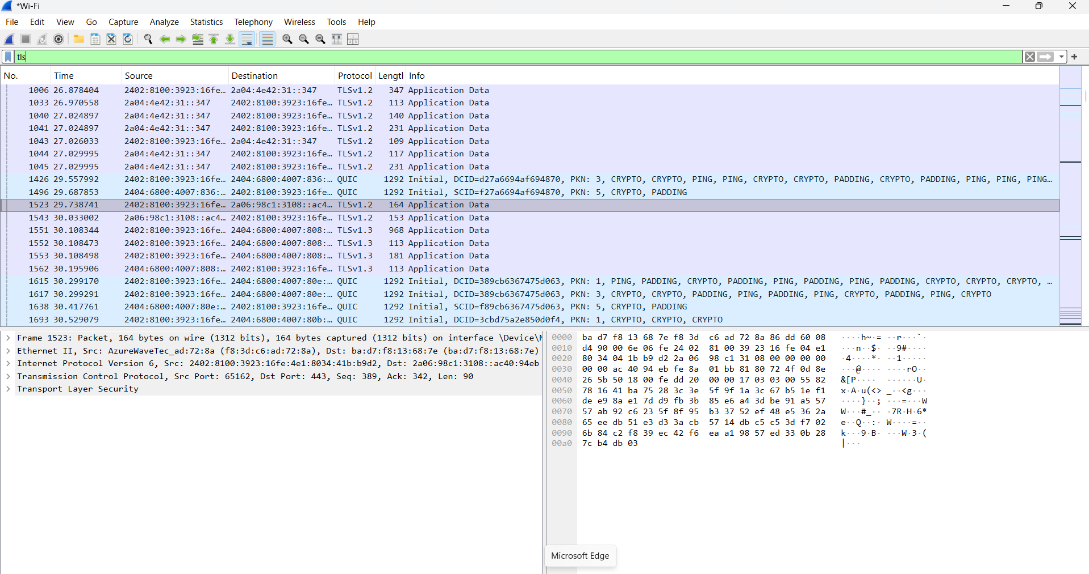

TCP
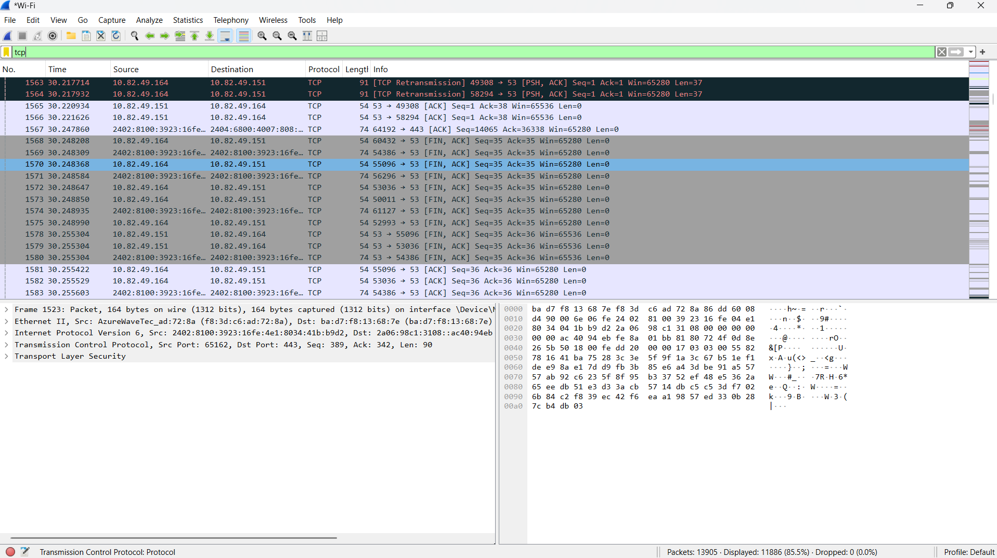

DNS
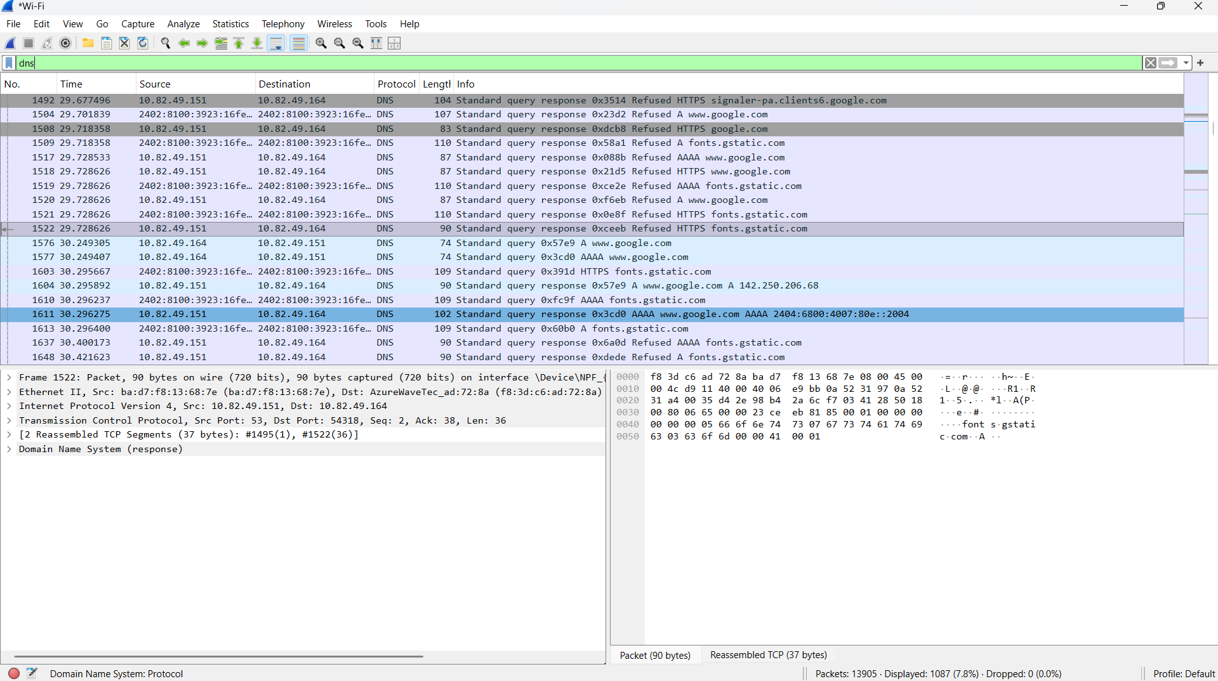

UDP
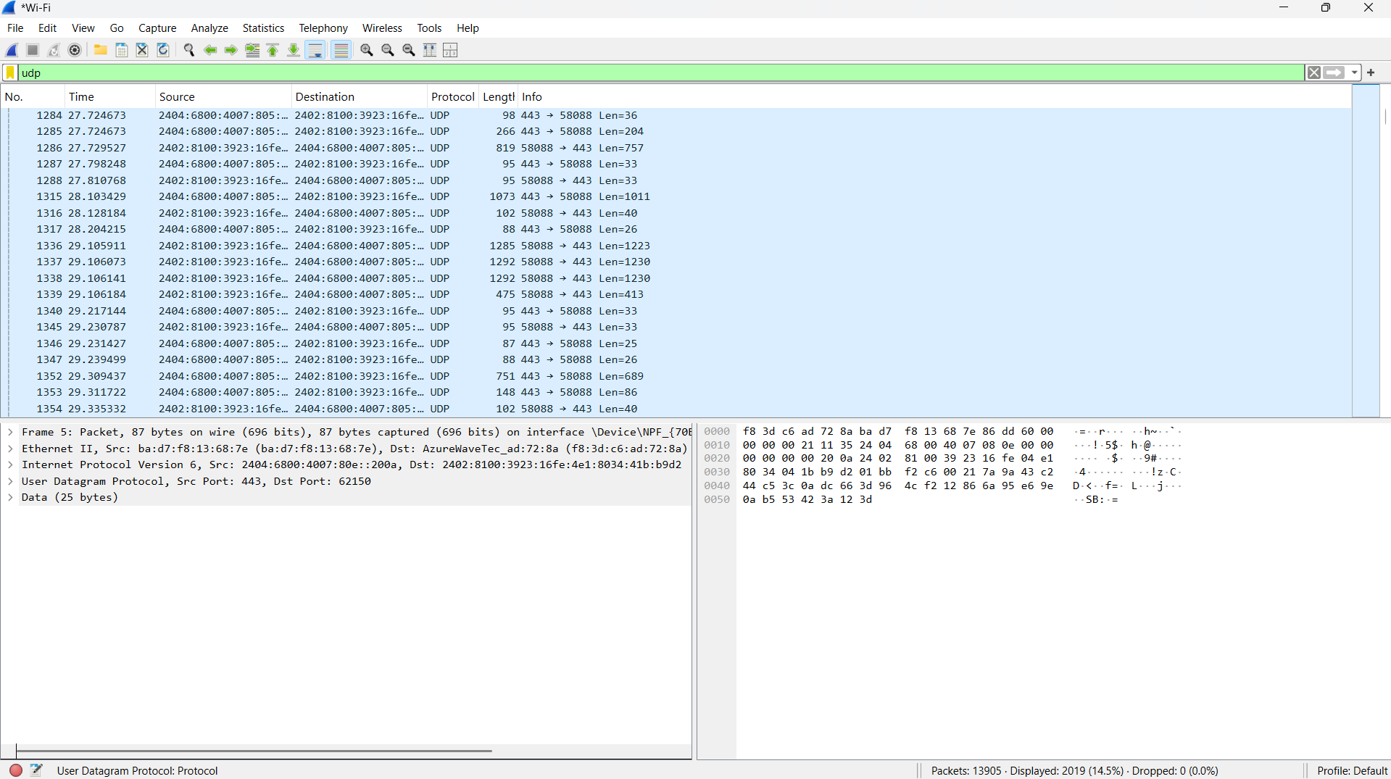

FTP
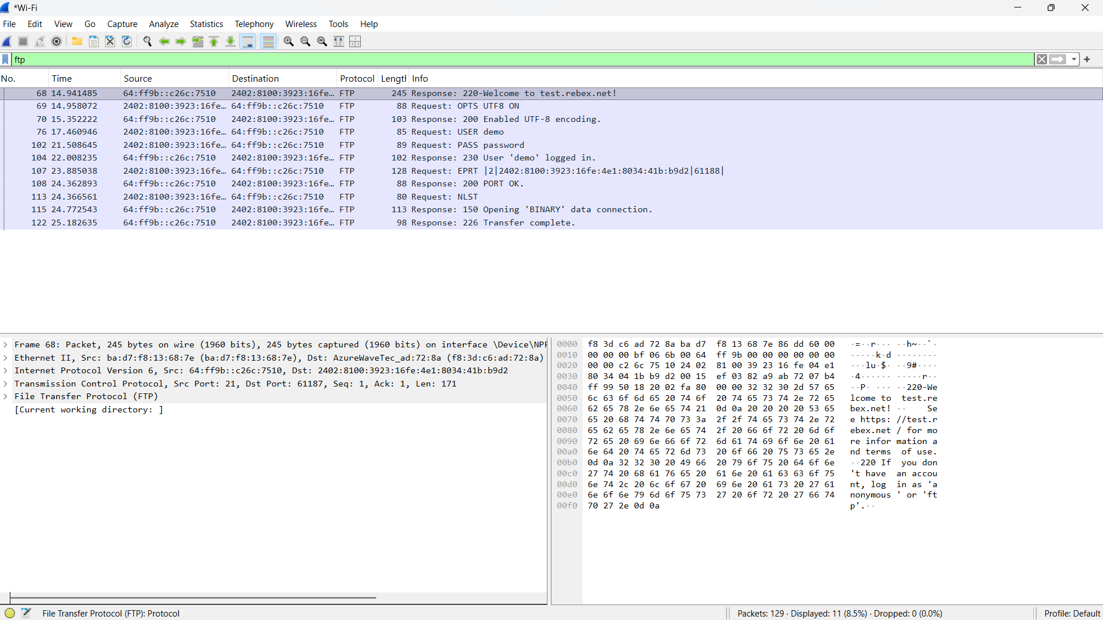

Three Way Handshaking
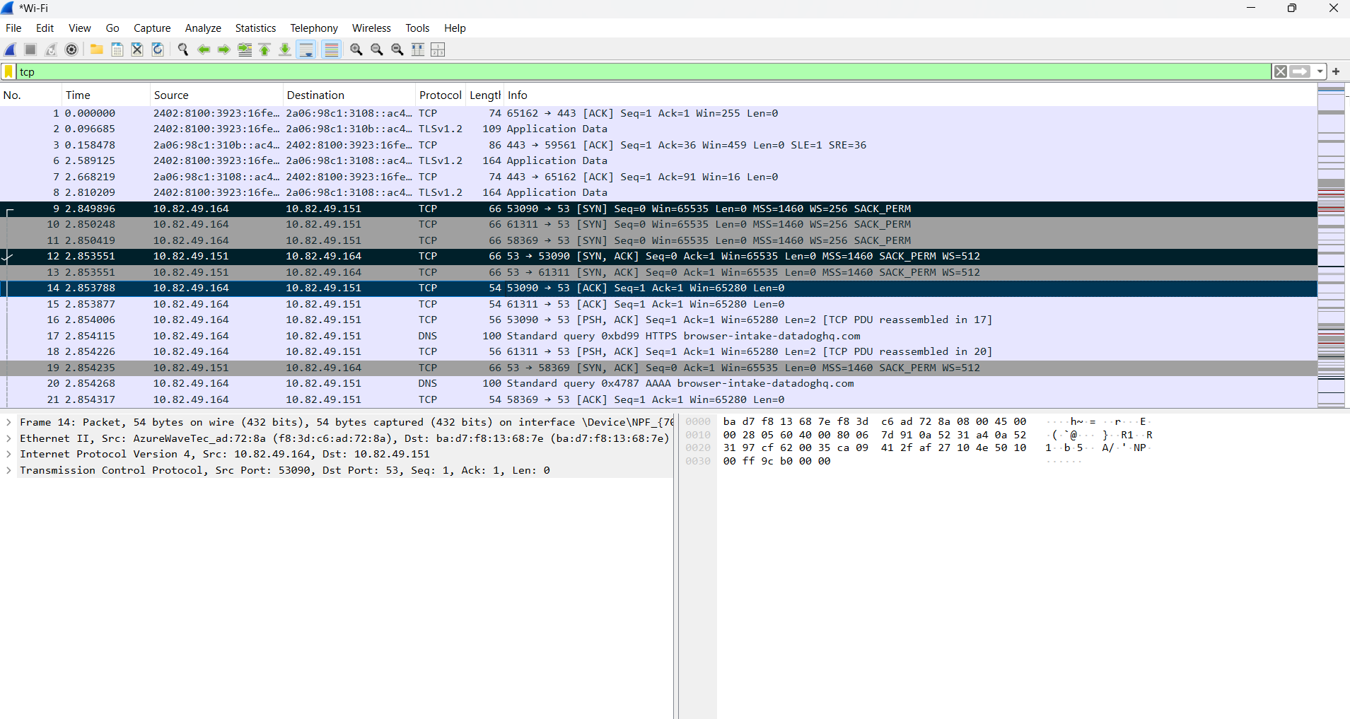

ICMP Echo Request/Reply

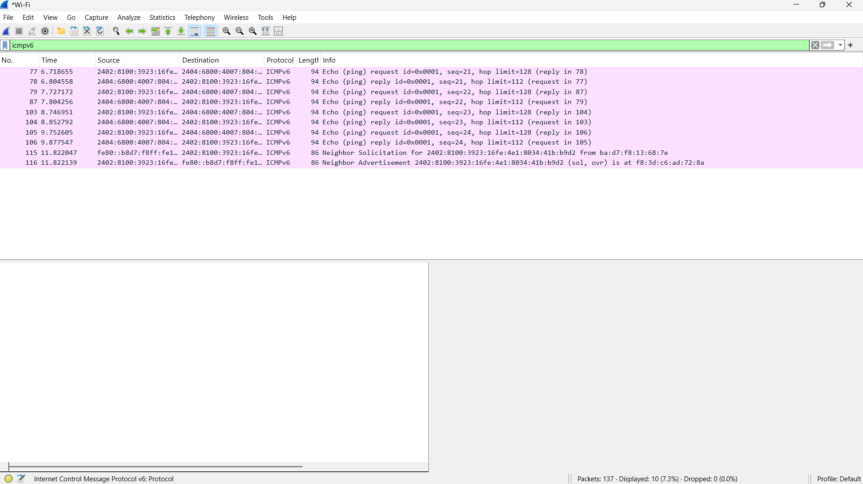

Highest Number of Packets Shared Between Two IPs
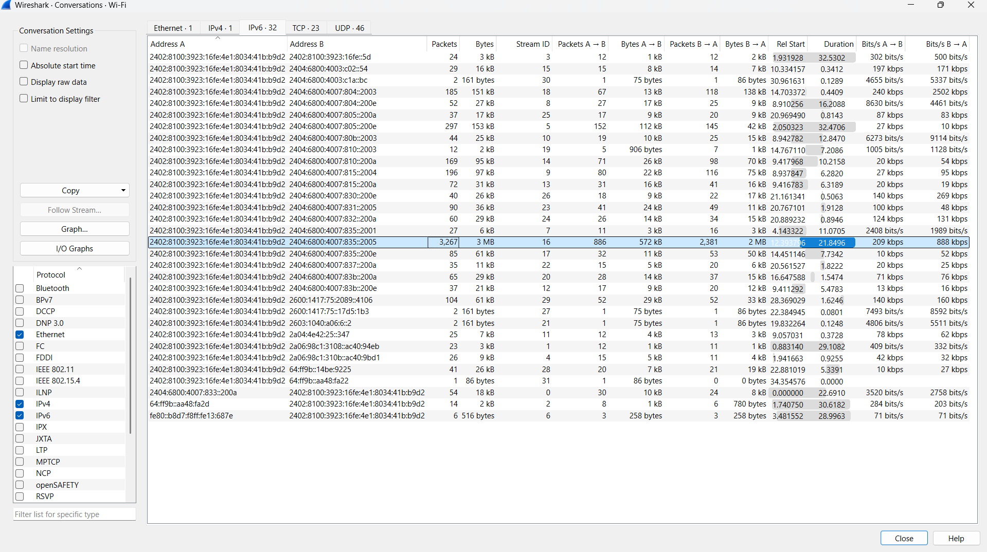
Most Packets Shared IP
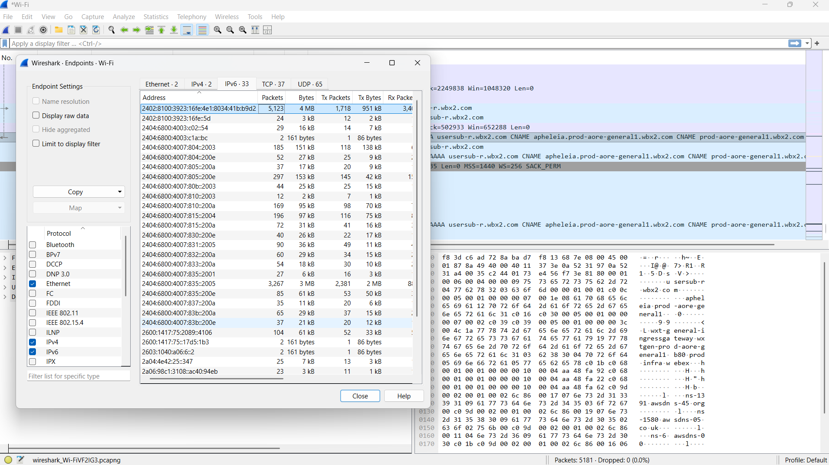
Flow graph of threewayhandshaking

